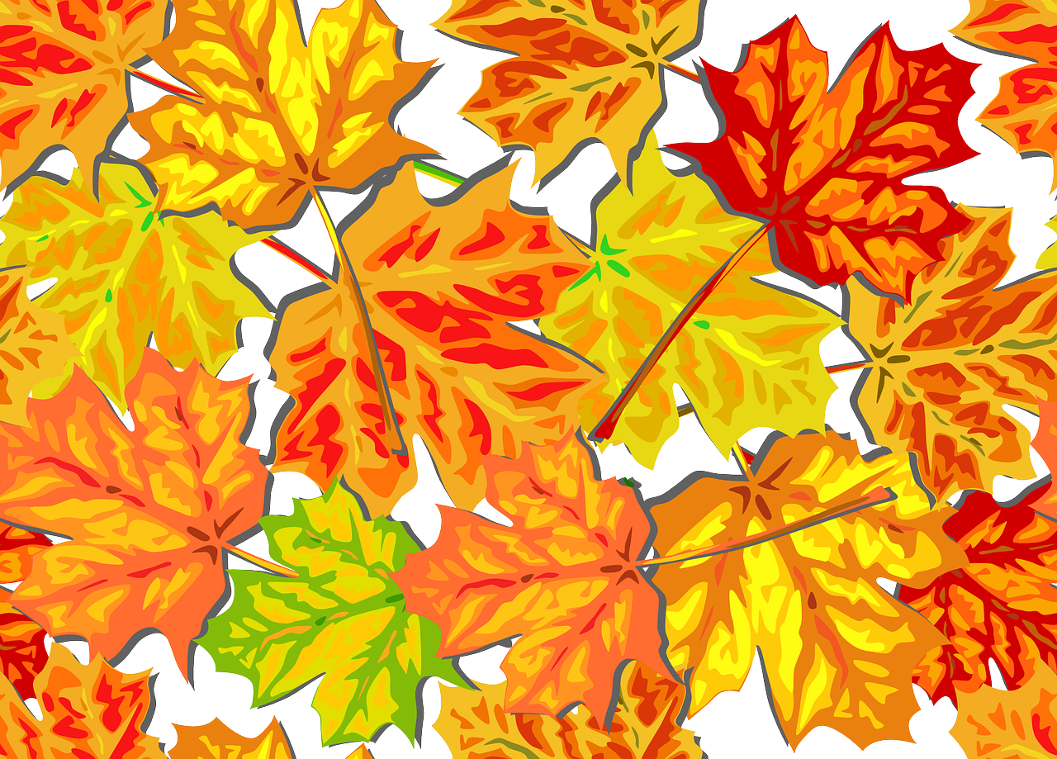
TOWN OF GUERNSEY
FALL CLEAN UP WEEK
Fall is here and Old Man Winter is on his way. Fall Clean Up Week has arrived once again and that means time to get the garden/yard waste, unwanted items and recyclables ready to be picked up. The Town of Guernsey’s Annual Fall Clean Up Week is October 16, 2020 thru October 23, 2020. All FREON items and REGULAR TUBED TVS AND MONITORS will need a BULK sticker. Please contact Town Hall and get on the list to have your items picked up. We will have 3 30-yard roll-offs placed at the Town of Guernsey’s old landfill. There will be personnel at the landfill to assist those who bring out their items on Saturday from noon - 2pm.
ITEMS NOT ACCEPTED:
ASBESTOS; WIRE FENCING BATTERIES; SOD
CEMENT CABLE/WIRE; ROCK
NO ANIMAL/BODY PARTS TIRES; DIRT
PAINT/SOLVENTS/ETC. ROOFING/TAR PAPER

THERE WILL BE A $40.00 CHARGE FOR ALL FREON-CONTAINING ITEMS AND THERE IS A CHARGE OF $25.00 FOR ALL REGULAR TV'S AND MONITORS. PLEASE CONTACT THE TOWN TO MAKE ARRANGEMENTS FOR PICK UP OR STOP IN AND SEE US.

IF YOU HAVE ANY QUESTIONS PLEASE FEEL FREE TO CONTACT TOWN HALL AT 307-836-2335

